Chat Website Project Proposal

By

Ibrahim Andrew Audu

M00650284

Web Applications and Databases

**Abstract**

This is a proposal for a single page chatting website. I plan to design the website the chatting application will run on and the chatting application itself. The website will be created based on all the skills learned from the Web Applications and Databases module being at the university at the moment.

**Description of the Website**

The website will be written in HTML, CSS and JavaScript. Depending on what functionalities I want to achieve when designing the website, I might have to write in PHP as well.

The website is a single page website where any user can login with their preferred username and send messages in a chat/message box. A user must login with a Username first, before a Message can be send to the chat/message box. Every message sent to the chat/message box shows who sent the message and a time stamp of when the message was sent. The logged in user has the option of logging out at any point in time. There will be an ‘Exit Chat’ option to leave the current chat a user is currently on.

**Other Functionalities**

Concerning functionalities, find the two that have been identified and I am interested in implementing below. Every other special functionality implemented will be detailed in the final report.

* **Archiving of Chats**

As informed by the lecturer of this module, adding such function will fetch more marks for Data and JavaScript complexity. I will attempt to implement this functionality into my chat website within the timeframe of the project. This functionality involves the storage and backup of chats.

* **Creating Multiple Chatrooms**

As stated in ‘Archiving of Chats’, adding this functionality to my website will fetch more marks. Hence, why it is mentioned here. I am a bit doubtful about it, but it’s one of the extra functionalities I plan to have for my chat website. The user can switch in between different chat rooms on the website once they’re logged in.

**Database**

For this project, I will be using MySQL as the database. Through carried, I have discovered that it will provide the easiest compatibility considering MongoDB is not allowed as a choice.

**Wireframes**

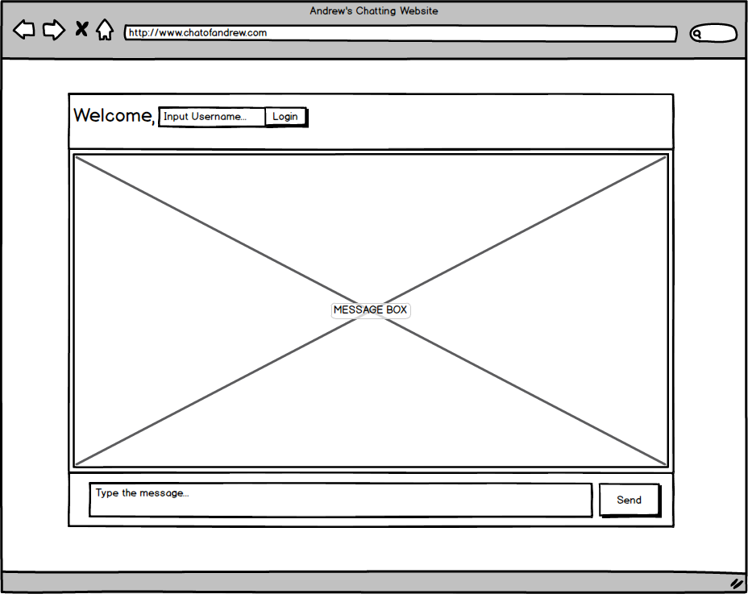

* ***Fig. 1(a). Index Page (not logged in).***

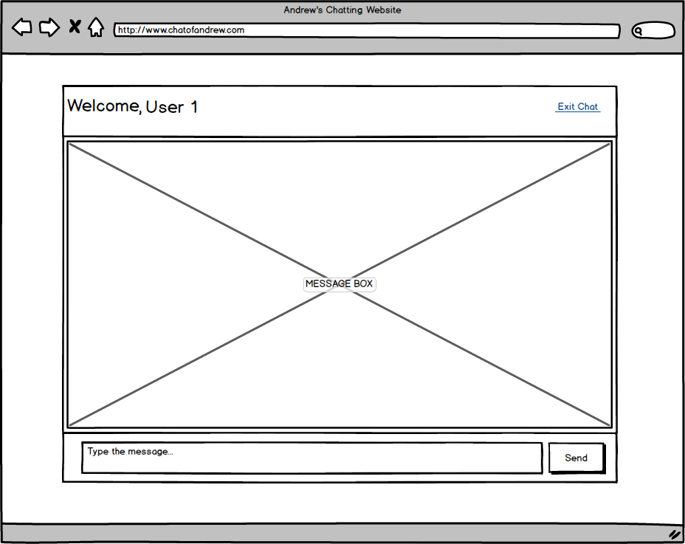

* ***Fig. 1(b). Index Page (logged in).***

**Samples of the Website**

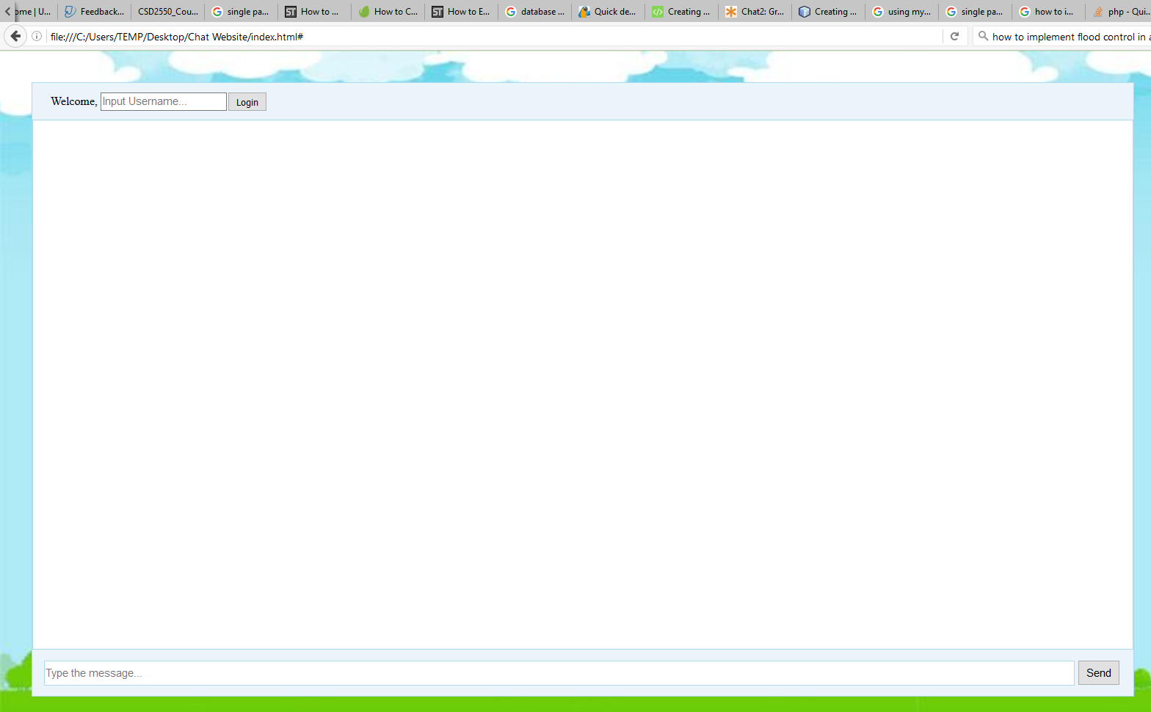

* ***Fig. 2(a). Index Page Sample Screenshot (not logged in).***

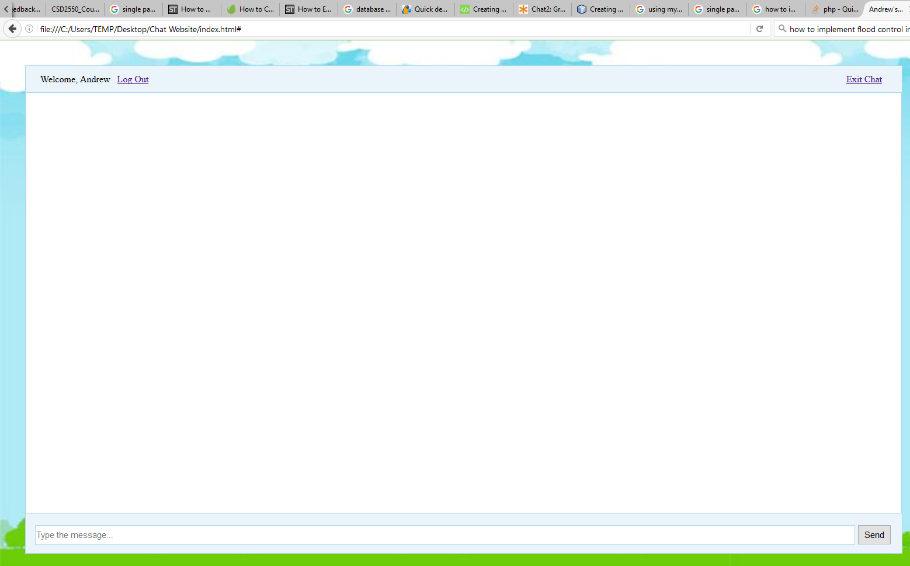

* ***Fig. 2(b). Index Page Sample Screenshot (logged in).***